# Part 1

For each source, the preparing data segment prepares the data array to pass into the Figure constructor. Essentially, most of the code is abstracted to be pretty similar, while the preparing data segment is unique and helps us put the data together in a way that our library likes.

# Part 2

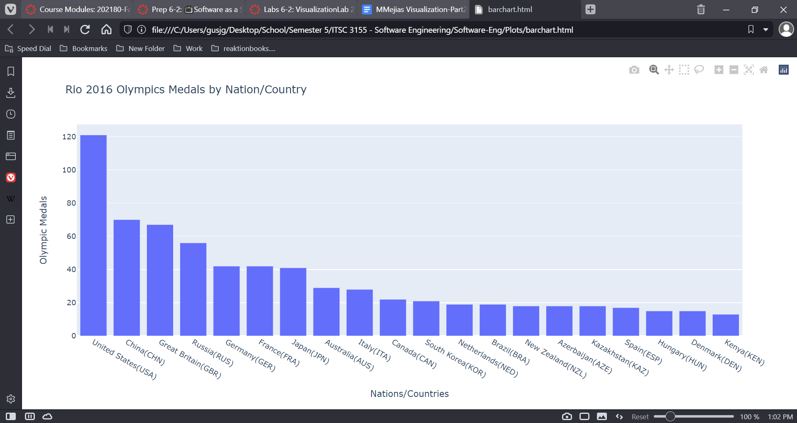

# Part 3

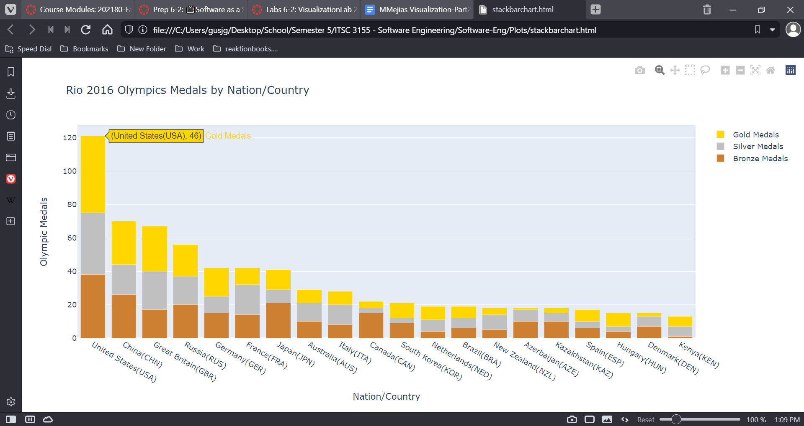

# Part 4

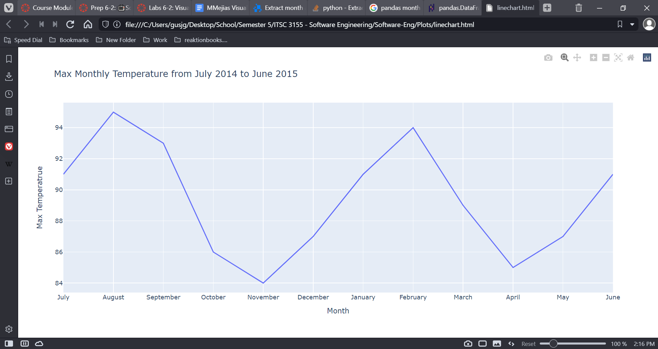

# Part 5

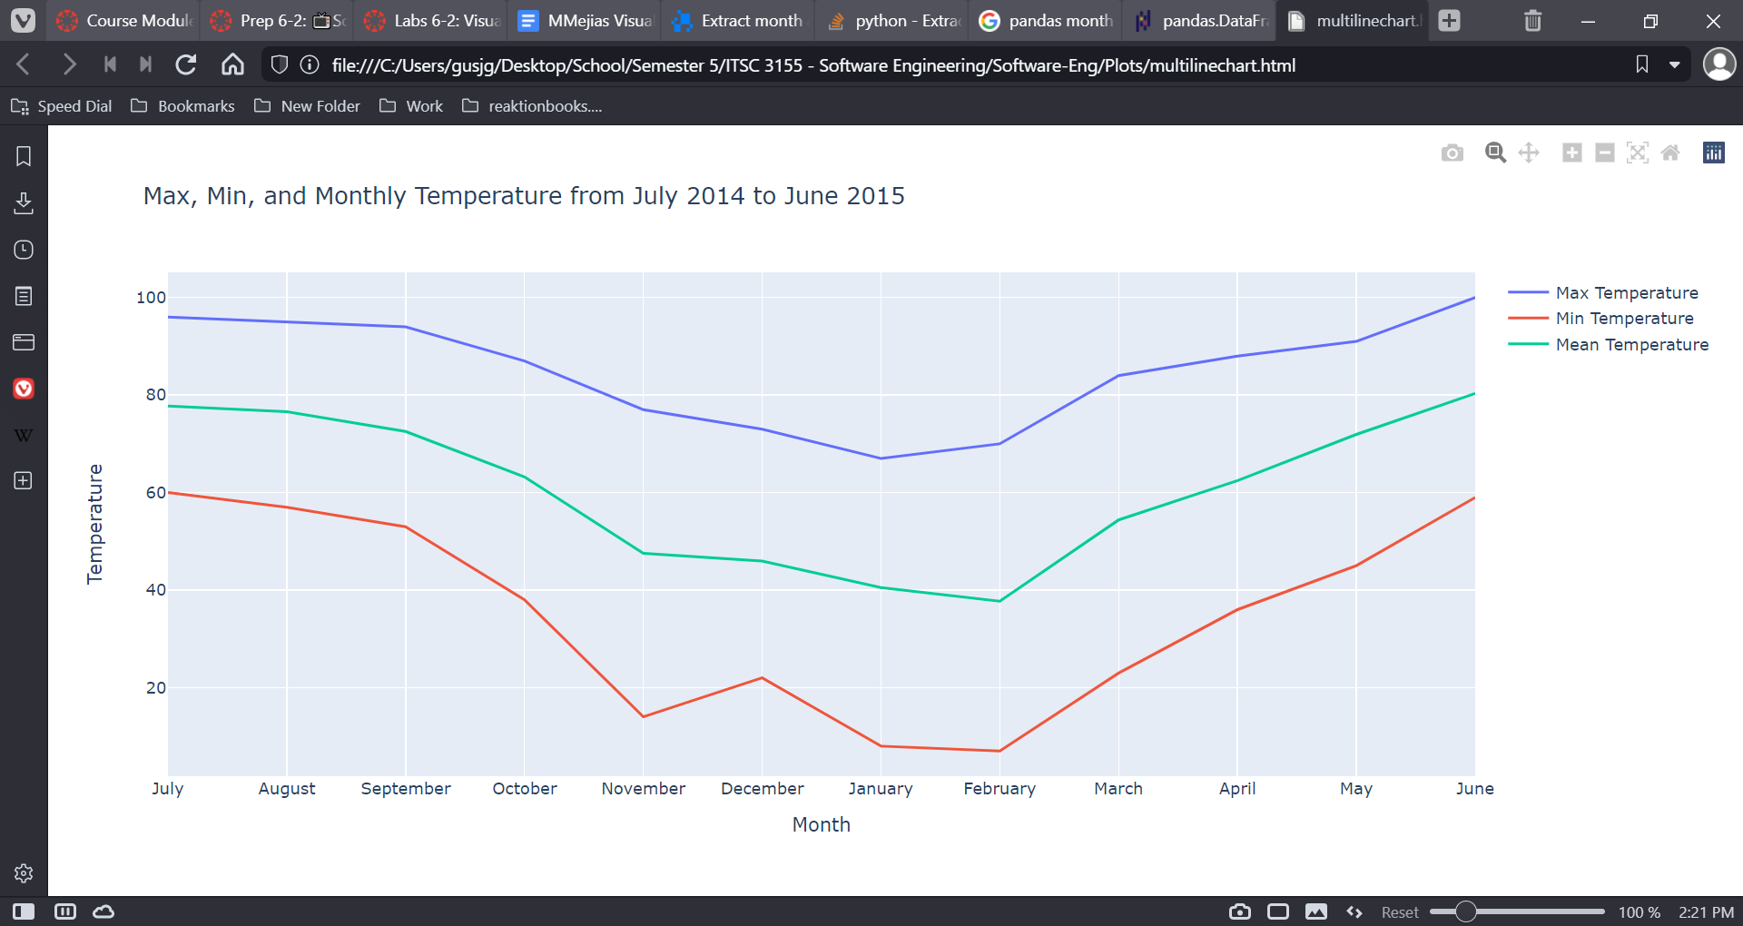

# Part 6